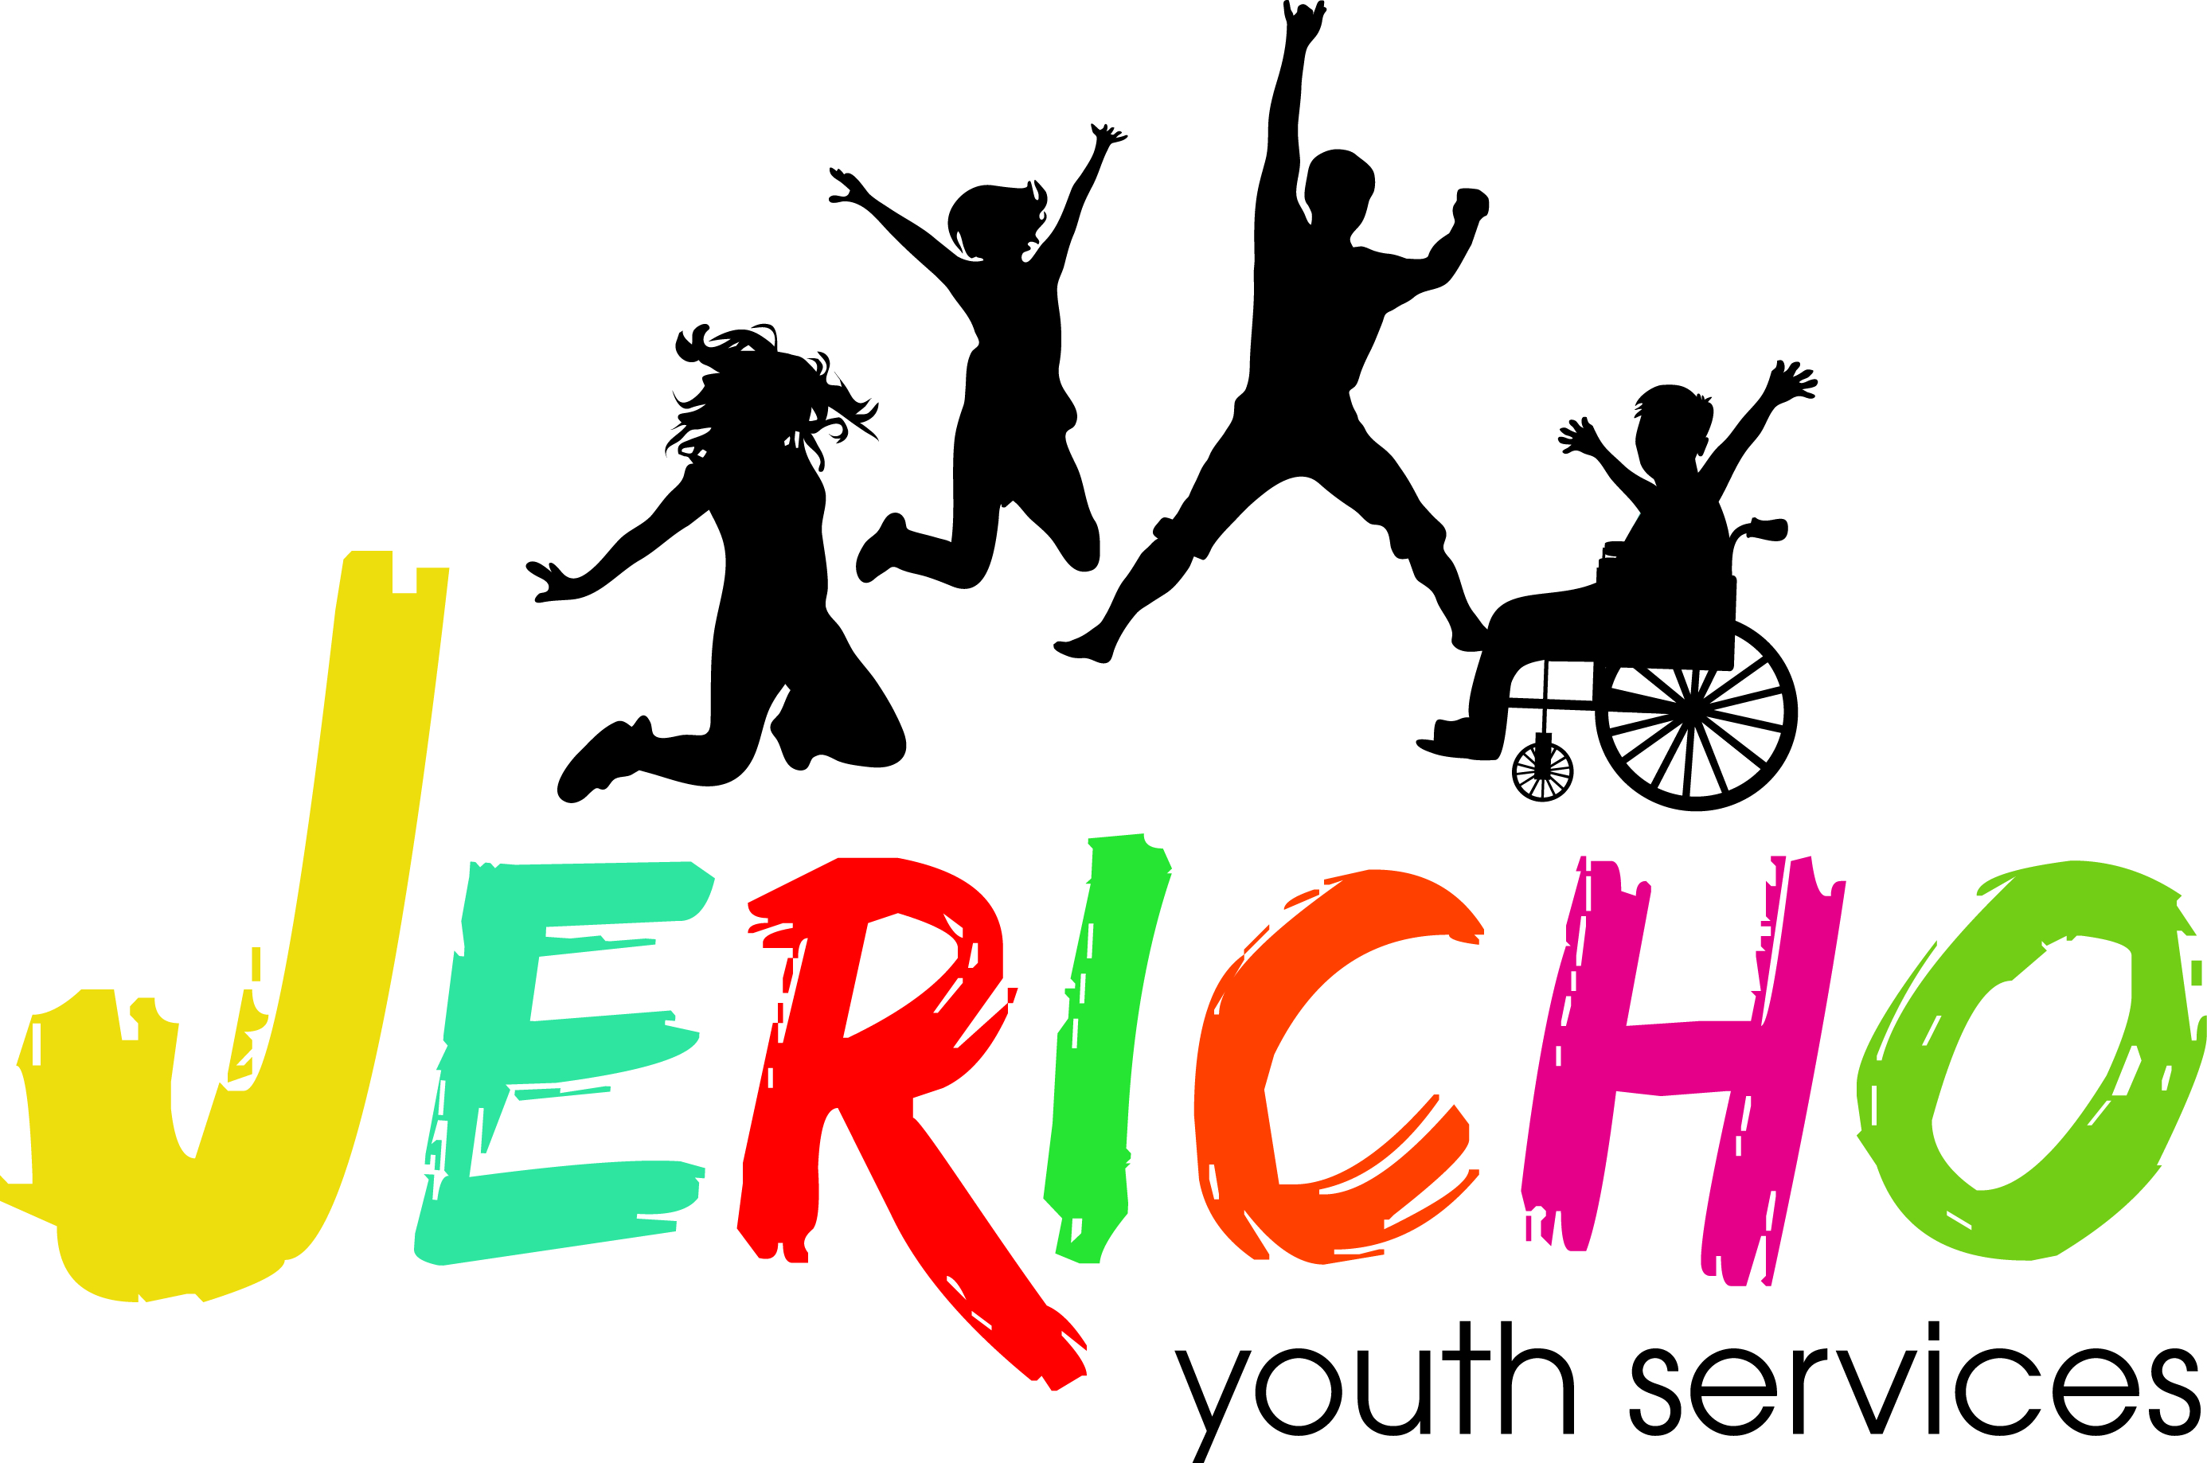
Parent Guide
After School Programs

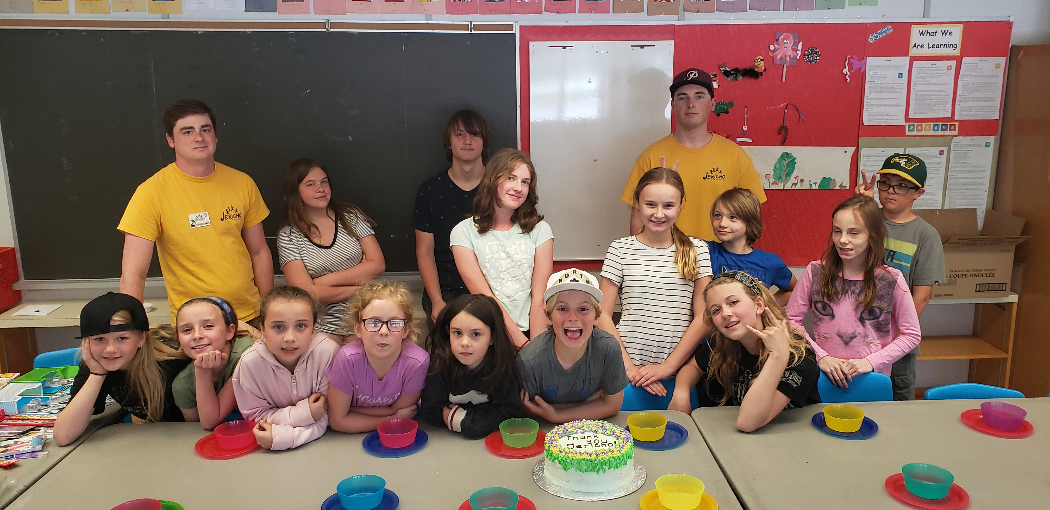

Dear Parents and Guardians
This parent handbook is your guide to assist us in providing the best experience possible for your child(ren) this school year. Please take the time to review the handbook and keep it on hand throughout the year as an information resource.
Our Mission
To provide children and youth with opportunities that enhance well-being through social, emotional and physical development by providing affordable and safe programs.
Our Vision
To educate and empower our youth in becoming engaged and caring citizens of the community.
Our Values
Accountability, Dedication, Integrity, Leadership, Respect

There are a lot of exciting activities planned for the year, and to ensure that you are well prepared, we have put together a list of necessities your child(ren) will need to bring with them.
Things to send everyday:
- Running shoes, a hat
- Extra drinks (water, water, water)
- Please leave toys and electronics at home
- Proper outdoor clothing according to the season (jacket, boots, snowsuit, etc.)
Jericho Youth Services believes that our After School program provides your child(ren) with the opportunity for healthy growth and development and to thrive in socialization. We see parents/guardians as partners in this adventure and welcome your suggestions and comments. Please introduce yourself to our program staff and get to know them. Each of our staff has been carefully selected based on their skills, talents and commitment to healthy child development. They will be happy to answer any questions you may have.
Please feel free to contact me anytime if you have any questions or concerns
Sincerely
Chantelle Oosterhuis
Program Coordinator
905 722 5540 ext 5519
Chantelle.oosterhuis@jerichoys.org

Table of Contents Pages

Parks & Recreation Ontario – Principles of Healthy Child Development . . . . . . . 4

Supervisors & Program Leaders . . . . . . . . . . . . . . . . . . . . . . . . . . . . . . . . . . . . . . . 5
Supervision Ratios
Concerns & Suggestions

Program Hours . . . . . . . . . . . . . . . . . . . . . . . . . . . . . . . . . . . . . . . . . . . . . . . . . . . . . 6
Program Hours
Arrival & Departures
Authorized Pick up & Emergency Contacts
If your child is unable to attend

Ensuring Positive Experiences . . . . . . . . . . . . . . . . . . . . . . . . . . . . . . . . . . . . . . . . . 6
Participants’ Safety
Program Plans
Lost & Found
Extreme Weather & Snow Days

Behaviour Management Policy . . . . . . . . . . . . . . . . . . . . . . . . . . . . . . . . . . . . . . . . 7

Medication . . . . . . . . . . . . . . . . . . . . . . . . . . . . . . . . . . . . . . . . . . . . . . . . . . . . . . . . 7

Children with Special Needs . . . . . . . . . . . . . . . . . . . . . . . . . . . . . . . . . . . . . . . . . . 7

Preparing your child for a day at camp . . . . . . . . . . . . . . . . . . . . . . . . . . . . . . . . . 8
What to bring
Money & Valuables
Snacks
Sunscreen Policy
Bus Trips
Bus Trip Supervision

Program Evaluation . . . . . . . . . . . . . . . . . . . . . . . . . . . . . . . . . . . . . . . . . . . . . . . . 8

Parks and Recreation Ontario – Principles of Healthy Child Development$®$

Jericho Youth Services believe that recreational programs and sports provide your child with the opportunity for healthy growth and development. To ensure the programs are of the highest quality, we incorporate the HIGH FIVE® principles of healthy child development into all program designs.

Principles of Healthy Child Development$®$
A Caring Adult: Acts as a positive supportive role model with helping children ages 6 to 12 years develop positive social skills, self-esteem and self-confidence.
Play: Stresses fun, creativity and cooperation. Play allows children to shape their environment, use their imaginations and enjoy the activities they are involved in.
Friends: Friends help introduce children to the bigger world beyond their family, share in humour, test loyalty from their first audience and offer support and criticism. Within the supportive/caring relationships characteristic of effective programs, a positive peer interaction was the second most frequently cited attribute.
Participation: Involves children in the planning and implementation of activities, helping them feel involved, independent, and competent.
Mastery: Develops self-esteem and positive identity in children.

Supervisors & Program Leaders
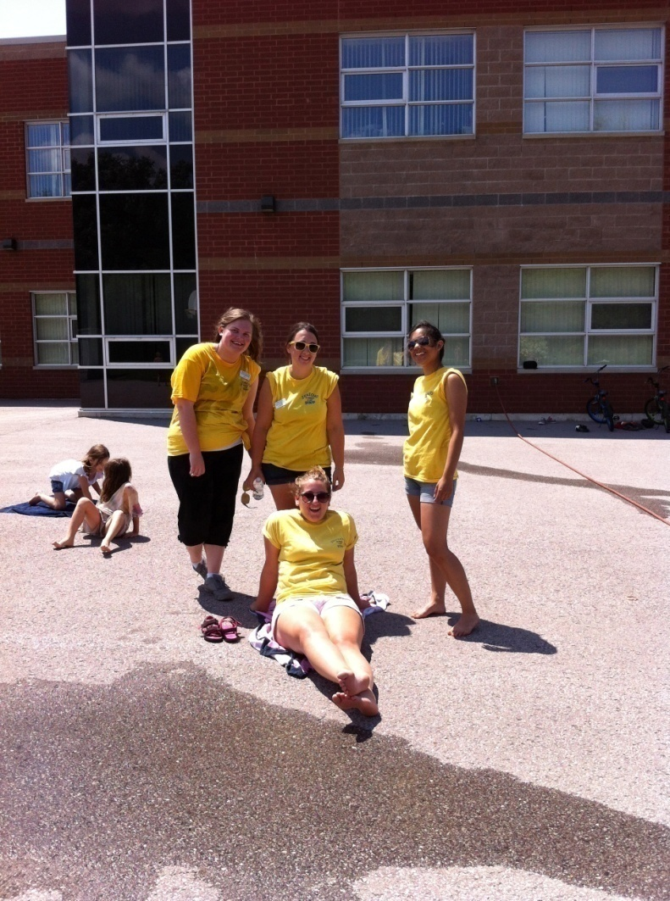
A caring leader is an essential component in ensuring a positive day experience for your child. You will take comfort in knowing that all Jericho staff goes through a thorough screening process including an interview, reference checks and vulnerable sector screening checks.

All of our Jericho Youth Services staff members are certified in HIGH FIVE®’s – Principles of Healthy Child Development. This provincial training program focuses on understanding children and how to create programs that support their development.

In addition to the HIGH FIVE® training, all of our program staff hold a current Standard First Aid CPR Certificate and we provide an extensive training program which include topics such as program planning, understanding child behaviour, problem solving, planning special events, working with children who have special needs, emergency procedures as well as practical experience leading games, crafts and singsongs.

Supervision Ratios
Our staff/child ratios reflect our commitment to safety and high quality program supervision. Our after school programs operate with a maximum ratio of one leader to every 10 children (1:10). In some cases, ratios are supported with our volunteers, all of whom have completed the volunteer screening process in accordance with the Jericho Youth Services Policy.

Concerns and Suggestions
If you have any concerns or suggestions regarding any aspect of our program throughout the year, please do not hesitate to talk to the Program Supervisor. They are responsible for the direct supervision of all participants and staff as well as handling any concerns or questions parents/guardians may have. Please also feel free to contact the Community Development Coordinator Lindsey Jones at 905 722 5540 ext 105, who is responsible for the operation of all our program locations.

Program Hours
Our After School programs run from right after school until 5:45pm for most sites. Our Morning Glory P.S is over at 5:15pm.

Arrival and Departure
Your child(ren) will be signed in by one of the staff members every day. Parents/guardians must sign out your child(ren) at pick up with one of the Jericho staff members. With your written permission, participants can walk home after the program. Please inform Program Supervisor in advance if your child is unable to attend the program. Jericho staff will follow up with a phone call if an expected participant has not arrived.

Authorized Pick up and Emergency Contacts
At the time of enrollment you will be asked to provide the names and contact information including telephone numbers of any adults 16 years of age or older that you authorize to pick up your child or come to the program in the event you cannot be contacted when your child is ill or has been involved in an emergency. Please make sure to keep your Recdesk file up to date. If you require an alternate person to pick up your child who is not on the list please provide this information in writing to a Jericho staff member.

If Your Child is Unable to Attend
It is important for us to know if your child is unable to attend our after school program. Please send a note with your child (in advance if possible) so we can plan accordingly and advise his/her supervisor not to expect them. If your child is ill, please call the Jericho Youth Services office at 905 722 5540 ext 5519 to advise us that they will not be attending. We will inform the location Supervisor immediately. Please do not send your child to program when they are sick. If your child is not able to fully participate in the program due to health reasons (i.e. flu) you will be called to come pick them up.

Late Pick up
Jericho staff members are counting on you to be on time to pick up your child at the end of the program so that they can meet their personal and family obligations. We do understand that weather and traffic accidents happen, however please make arrangements for an alternate adult to pick up your child. An administration fee will apply for consistent late pickups.

Ensuring Positive Experiences

Participant’s Safety
Jericho staff members are trained to inspect each site daily for any potential hazards. Activities and games are planned with participant’s safety in mind and are always watched to ensure that safety standards are maintained. All program sites have access to a telephone and all programs have a First Aid Kit. All staff holds current First Aid Certifications. In the event of a minor injury to your child – scraped knee etc., staff will apply basic first aid by cleaning the wound and applying a bandage. In the unlikely event of serious injury to your child, emergency services will be called immediately to respond to the situation. You will be contacted immediately with information regarding the incident. If an ambulance is required to transport your child to the hospital, a member of our staff will accompany your child.

Program Plans
We want you to know what we’ll be doing. Monthly program plans will be posted on the Parents’ Boards at each location. Should you have any questions or suggestions regarding these plans, please see the Supervisor or Program Leaders at the location.

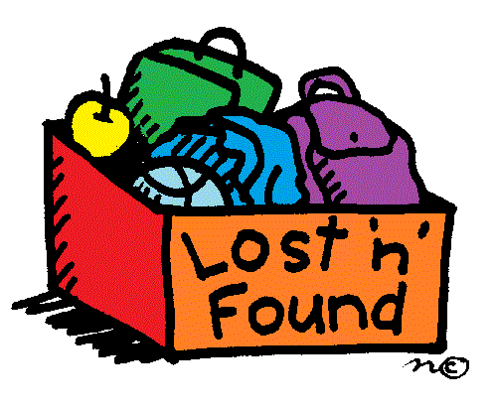
Lost and Found
Each program location will have a lost and found box. Please check the box regularly to see if anything belongs to your child. Please put your child’s name on all of their belongings to assist us in finding the rightful owner. Any items not claimed by the end of summer will be donated to charity.

Extreme Weather & Snow Days
During extreme weather conditions, advisories or alerts, (heat, smog or wind chill) the Jericho staff follow the guidelines of the local health department. Our first priority is to keep the children safe from serious adverse health effects such as frostbite and sunburn. Jericho staff will adjust the amount of time spent outdoors or provide an alternative indoor plan. When the school buses are cancelled, our programs will be cancelled for that day.

Behaviour Management Policy
We believe that positive program experiences strengthen and build each child’s self-esteem. Jericho staff members are dedicated to providing your child with a creative and innovative day at program which will keep them involved and engaged.
Behaviours that do not contribute to the well being of the participants and the staff will be tracked with our behaviour management system, “Working Towards Positive Behaviour”. The purpose of these forms is to work with the child to change their behaviour at our programs. Your support is appreciated in having a follow-up discussion with your child.

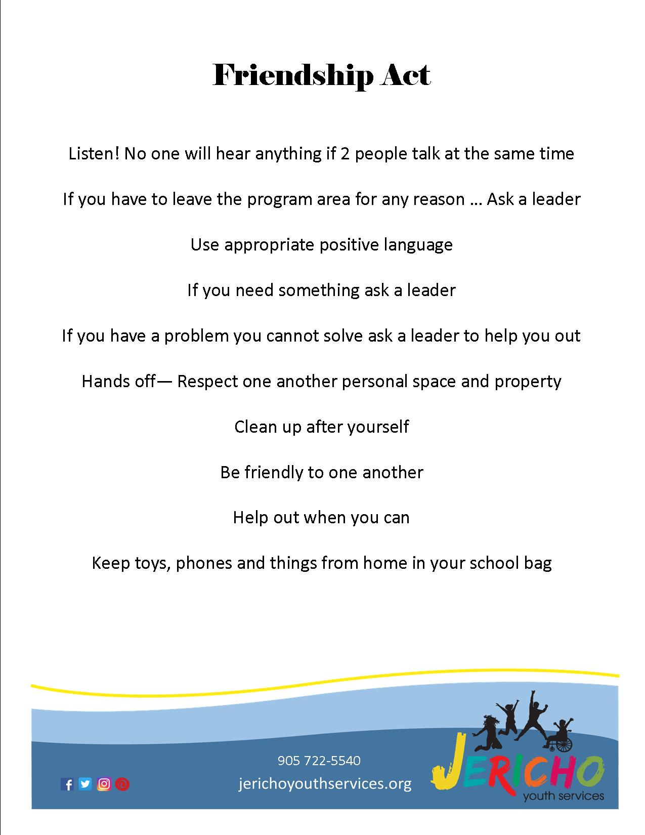
Based on the intent and severity of the incident, a participant may be withdrawn from the program. As confidentiality in this process is key, Jericho staff are instructed to keep forms in a secure location and do not share the information with individuals outside the program setting.

Friendship Act
Jericho Youth Services has a set of guidelines that all children at our programs are required to follow, called the Friendship Act. Supervisors and Jericho staff members will go over the Friendship Act with the group the first week of programs and when needed. These are posted at all of our programs for parents/guardian and children to see.

Medication
If your child requires medication during the program, a Schedule Medication Dispensing form must be completed. These forms are available from the Supervisor at the program location. Only medications prescribed by a physician will be considered for administration by our staff. Medication must be stored in its original container with appropriate dosage and directions for administration on the label.

All medication must be signed into the care of the Supervisor by the parent or guardian. The medication will be secured in a lock box and will be signed back into the care of the parent or guardian at the end of the day or week as requested. Medication such as epi-pens and asthma puffers will be carried by the supervisor or carried by the participant if indicated on the Schedule Medication Dispensing form by the parent or guardian. Staff cannot administer medication but will supervise participants capable of administering their own. In case of a life threatening situation where the participant is unable to administer medication such as an epi-pen or asthma inhalers, staff will assist.

Children with Special Needs
If your child has a special need or health condition we ask for your help in letting us know well before the first day of program. Please contact us at 905 722 5540 to discuss how we can best provide the support your child needs.
Jericho does offer an Inclusion Facilitator for children that require support. Inclusion Facilitators will work with the child to ensure that they are integrated into the daily program. It is the responsibility of all program staff to work with the Inclusion Facilitator to make the program experience the best it can be for all participants.

Preparing your Child for our programs

What to bring
Your child should bring the following each day: running shoes, a hat, sunscreen, extra drinks (water, water, water) in a backpack, with the participants’ name on it!
Money/Valuables
The Jericho staff are not responsible for any money or valuables brought to program. We strongly discourage participants from bringing any electronic devices (i.e. video games, iPods, cell phones, cameras, etc) and money. If a participant does bring any of these things to program, they will be asked to put them away. If a participant rides their bike to program, it is the individuals’ responsibility to ensure the bike is left in a secure location during program hours.

Snacks
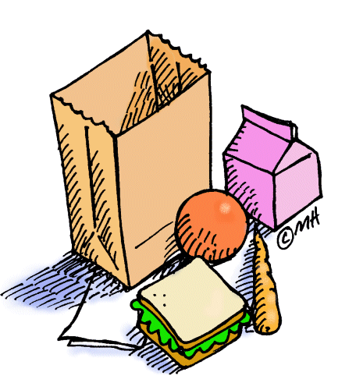
Jericho will provide a healthy, nutritious snack every day of program. As part of our attention to the participants’ safety, we have regular water breaks, so please pack a water bottle. Due to the number of nut related allergies of our participants and staff, peanut butter, nuts and foods that contain nut by-products will not be allowed at program.

Sunscreen Policy
We are all concerned with the damaging effects of the UVA and UVB. For this reason, we request that parents send sunscreen, sunglasses and hats with their children. Jericho staff members will periodically check to ensure that participants are wearing sunscreen. In order to assist the staff, please ensure your child knows how to apply sunscreen to his/her body.

Bus Trips
Our P.A Day Camps sometimes will have a trip planed. A trip wavier must be signed by a parent/guardian; the supervisor will have a copy of this form and can be found on our website. The safety and whereabouts of each participant is our primary concern during trips. All procedures are reviewed with the participants ahead of boarding the bus, including rules about behaviour on the bus, safety and the buddy system. Packed lunches are required for all trips – no lunch items will be purchased.

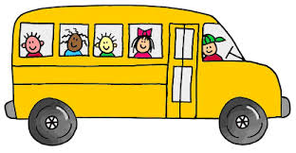
Bus Trip Supervision
We maintain our 1 staff member to 10 participant’s ratio on all trips. This ratio is enhanced to include the added support of youth volunteers from our Volunteer Program. To ensure the safety of your child, only Jericho staff will be allowed to supervise your child on trips.

Program Evaluations
We care about what you think of our programs and we are always open to suggestions. Program Evaluation forms will be distributed to all parents. Please complete the form and return to the supervisor. Evaluations can also be dropped off in person at the Jericho Office, 1964 Metro Road, Jackson’s Point. Your assistance in completing the evaluation will help us to fine tune and to plan for next year.

Forms
Parents of participants must complete all forms as required.

